Virtual Eminescu Roundabout

Exploring the surroundings of the Eminescu Roundabout

Team members: Catîru Stefan, Cojocarescu Bianca Ioana, Grajdeanu Alexandru Cristian, Pal Alexandra

Similar products & Relevant Links(>=3)

**Name** Google Earth VR

**Url:** <https://store.steampowered.com/app/348250/Google_Earth_VR/>

**Relevant Features**

- VR application

- tries to duplicate real-life buildings

- involves VR exploration/visiting

**Name:** Wander (from Meta)

**Url**: <https://www.meta.com/experiences/2078376005587859/>

**Relevant Features**

- VR application

- Wikipedia integration for location-based learning

- it presents specific tourist objectives

**Name:** Brink

**Url:** <https://store.steampowered.com/app/1462520/BRINK_Traveler/>

**Relevant Features**

- travel experience that takes you to amazing natural locations in full 3D to feel like you're really there.

- A virtual guide to teach you about your surroundings

- (X)VR application

-------------------------------------------------------------------------------------

Main Features

**PRINCIPAL MAIN VERY IMPORTANT FEATURE:**

visit surroundings of the Eminescu Roundabout

* **Other features:**
* **data visualisation**
* **sound effects that make your experience more realistic (traffic sounds, maybe wind, birds, etc)**
* **traffic, nature animations**
* **AR features (mixed realities)**

User Journey - Step by step flow through app

1. When entering game, the player is in the center of the Roundabout
2. If moving around, he can see the surroundings
3. If indicates towards a point of interest, he can see data and some VFX/SFX.
4. If walking around, he dicovers more points of interest.
5. If a tram is passing by, the player can find out its route.

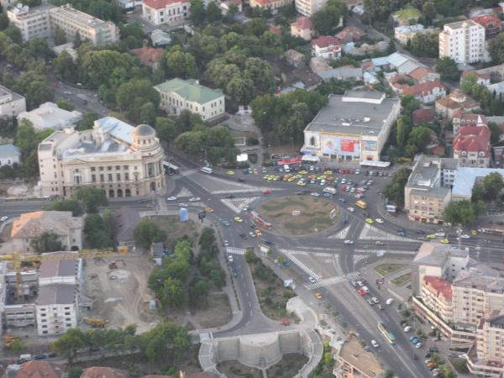Moodboard







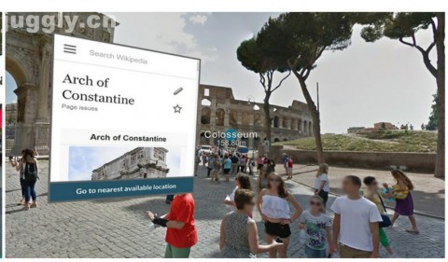

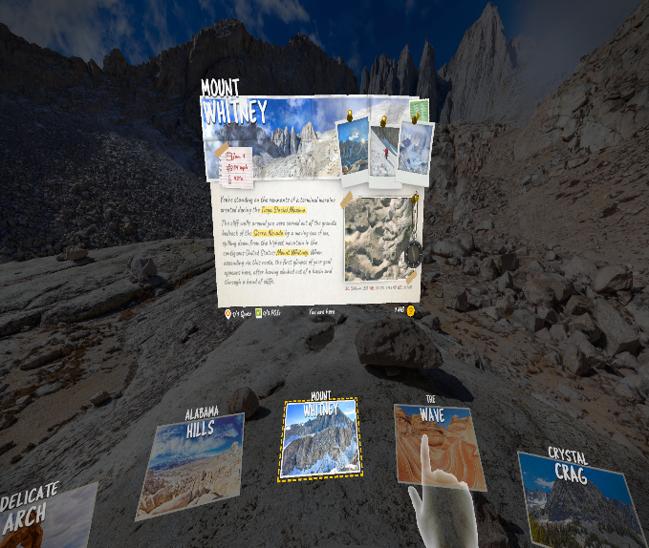

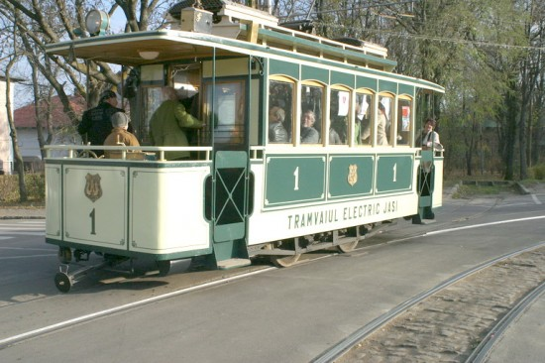

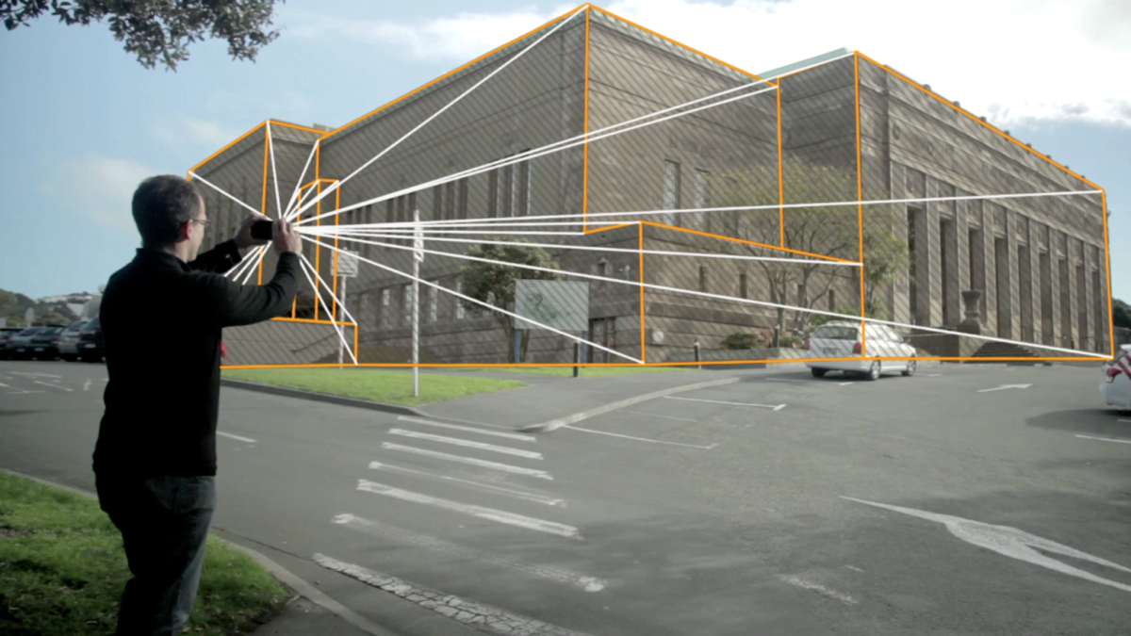

------------------------------------------------------------------------------------->>

Technologies, Libraries, Assets (>=5)

1. – Blender for modeling
2. – Unity for the entire project
3. - CSV, JSON or other compatible file format for data visualisation
4. - XR Toolkit
5. - ChatGPT (Dall-e 3)
6. - Midjourney
7. - Oculus integration
8. - Unity Asset Store
9. - EasyRoads3D
10. - TurboSquid
11. - TextMesh Pro
12. - Blender Kit